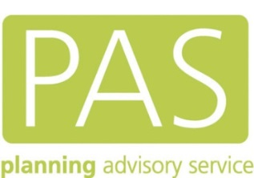

Planning for Shale Gas & Oil

MPA Officer and Councillor Workshops

March 2016

Time | Activities | Speaker
9.30 | Tea/Coffee
10.00 | Welcome, introductions and housekeeping | Stephen Barker
10.05  10.30  10.55 | A Brief Introduction to Shale Gas & Oil  Planning Applications for Shale Gas & Oil  Q&A | Gordon Halliday  Mary Campbell  GH and MC
11.10 | Tea/Coffee Break
11.25 | Breakout session – Solutions for the Challenges in Planning for Shale Gas & Oil  Introduction  Break-out session  Feedback  Q&A | Gordon Halliday  GH and MC
12.40 | LUNCH
13.30  13.50  14.30  14.45 | An Industry Perspective (Presentation)  Other Regulators (Presentations)  Q&A Panel with Industry and Regulators  Planning Performance Agreements  Introduction  Break-out session  Feedback  Q&A | UKOOG  EA/OGA/HSE/PHE  Mary Campbell  MC and GH
 | Tea/coffee available at 15.00
16.00 | Discussion Forum, round up and finish | GH, MC and SB
16.30 | Close

Name | Company | Job Title
Scott Bradley | DCLG | Shale Team Leader
Marcus Sparrow | Gloucestershire County Council | Senior Planning Officer
Jason Betty | Gloucestershire County Council | Senior Planning Officer
Gary King | Hampshire County Council | TBA
Russell Chick | Isle of Wight Council | Principal Planning Officer
Chris Mills | Isle of Wight Council | Planning Officer
Bob Blezzard | Isle of Wight Council | Councillor, Vice Chair of the Planning Committee
Philip Anelay | North Somerset Council | Planning Policy Officer
Laura Horner | Somerset County Council | Principal Planning Officer
Guy Robinson | Somerset County Council | Senior Planning Policy Officer
James Neave | West Sussex County Council | Principal planner
Heidi Brunsdon | West Sussex county council | Chairman planning
Mike Wilmott | Wiltshire Council | Area Development Manager

