

**Add logo here or delete this box**

Insert council name

Your guide to the Care Quality Commission assessment

for adult social care

Insert date

The **Local Government Association** and **Association of Directors of Adult Social Services** are **Partners in Care and Health** (PCH) working with well-respected organisations.

PCH helps councils to improve the way they deliver adult social care and public health services and helps Government understand the challenges faced by the sector.

The programme is a trusted network for developing and sharing best practice, developing tools and techniques, providing support and building connections.  
It is funded by the Department of Health and Social Care and offered to councils without charge.

**www.local.gov.uk/PCH**

Add supported by logo here or delete this copy

**Add logo here or delete this box**

Your guide to the Care Quality Commission assessment for adult social care

# 

# Introduction

The Care Quality Commission (CQC) assessment of adult social care is looking to see how the council is meeting its duties under Part 1 of the Care Act (2014).

When the CQC come to xxx, first and foremost we want you to be proud of the work you do every day to meet the needs of local people.

It will be an opportunity for you to tell them

* what you’re really good at
* what you are proud of
* where you are making a difference
* where we are striving to do better.

This short booklet aims to give you the information you need to understand the CQC assessment process for local authority adult social care, and what you can do to prepare.

It is also important to remember that CQC inspectors and members of the assessment team are people who want to help make services better and help the council improve. They will help us see with ‘fresh eyes’ where we are doing really well in meeting our duties and where we need to continue to make improvements.

Place holder for message from DASS

# What is the CQC’s approach?

Assessing how councils meet duties under Part 1 of the Care Act 2014 is a new responsibility for the CQC, which started in 2023. The intention is to assess each relevant council at least once in the first two years, using the learning to develop and refine the approach.

The framework used to assess how well we are meeting our duties was co-developed with partners, agencies and people with direct experience of using care and support services. It uses a subset of nine quality statements drawn from the CQCs overall single assessment framework, mapped to four themes.

Each quality statement is expressed as a ‘we’ statement describing what is needed to deliver high-quality, person-centred care, and ‘I’ statements describing what people should expect based on Think Local Act Personal’s ‘Making it Real’ framework.

During the assessment, the CQC will look at evidence that relates to the 12 months preceding the start of the assessment (although it may look at evidence outside the 12 month period if necessary, for example, organisational strategies and policies). They will be four evidence categories:

1. people’s experience, including unpaid carers
2. feedback from staff and leaders
3. feedback from partners
4. processes

The CQC will not be using evidence from observation or outcomes in the initial formal assessments.

Evidence will be gathered via three routes:

* what is nationally available – evidence from national data collections and other insights
* what is requested – information provided by the authority
* what is actively collected – for example case tracking, focus groups, conversations that is not available through other means

Once the CQC assessment team feel they have sufficient evidence to reach a judgement across each of the four evidence categories for each quality statement, they will not look for more.

The assessment starts when the CQC sends a notice of assessment and request for information – the “information return” (which is the same for all councils) and ends when they publish the report.

A flow chart for council audiences that shows the five sequential stages of a CQC assessment. Under each stage, there is a description of what will happen and what is expected of the council.


The CQC assessment team will include executive reviewers and specialist advisors who will work alongside CQC inspectors.

Executive reviewers will be substantively or previously employed within a local authority and will provide an expert peer perspective to inform findings and judgements relating to leadership and governance.

Specialist advisors will be managers and leaders currently working within a local authority or other relevant organisations able to provide specialist advice in relation to how a local authority is delivering its Care Act duties.

**Case tracking**

Case tracking is an approach to follow the pathway of a small number of people to gather evidence of their experience from when they first approach the local authority and it covers the assessment of their needs, care planning, moving through services (if applicable) the impact of the care, the outcome for the person and a review of their needs.

It involves reviewing care records and talking with the person and maybe their family, friends or advocate.

Case tracking will be used to help the CQC assessment team understand the lived experience of people using social care arranged through the local authority.

The CQC will send full guidance on the case tracking process, and they will select six people to speak to, plus four reserve people from the 50 cases provided by the council, who will be asked if they are willing to talk to the CQC.

Ratings will be determined by the CQC team by reviewing evidence against each quality statement and applying a score to each of the evidence categories which are then combined to give an overall percentage score and rating, and a rating for each quality statement.

## A line that depicts a spectrum of possible ‘gradings’ from CQC and the corresponding range of marks that go with each: 0 to 38 would deem a council to be judged by CQC as inadequate, between 38 to 62 is a ‘requires improvement’ status, 62 to 87 is labelled by CQC as good and 87 to 100 as outstanding. The Care Act 2014

The [**Care Act 2014**](https://www.legislation.gov.uk/ukpga/2014/23/contents/enacted) and care and support [**statutory guidance**](https://www.gov.uk/government/publications/care-act-statutory-guidance/care-and-support-statutory-guidance) is the legal framework for adult social care. It places a duty on councils to support and promote the wellbeing and independence of working age disabled adults and older people, and their unpaid carers and gives them more control of their care and support.  
  
A diagram that shows the ‘Care Act 2014 Principles’ as the centre point of CQC assessment. Around this centre point and connected to it and each other, are the six principles of the Care Act: Empowerment, prevention, proportionality, protection, partnership and accountability.

  
  
Phase 1 of the Care Act was implemented in April 2015 and included:

* a national level of care and support needs to make care and support more consistent across the country
* rights for carers on the same legal footing as those they care for
* a duty to protect adults at risk from abuse or neglect including establishing a safeguarding adults board
* a greater emphasis on prevention
* a requirement to provide clear information and advice, to help people make informed choices on their support arrangements.

New rights for people funding their own care and support, giving them access to information and advice and a range of universal and preventative services as well as an assessment free of charge.

A duty to shape the local provider market and a duty to temporarily ensure there is continuity of care in the event of service interruption as a result of business or provider failure and other service interruptions.

If you want a quick reminder of the Care Act, the Social Care Institute for Excellence produced [a short video](https://www.scie.org.uk/care-act-2014/video/) which gives an overview of the key aspects.

# The four CQC themes that will be used to assess our performance

The CQC assessment framework for local authorities comprises nine quality statements mapped across four themes.

The summary below sets out the quality statements and the areas that are being covered within each theme.

## Theme 1: Working with people

| ‘We’ statements | Scope |
| --- | --- |
| **Assessing need**  We maximise the effectiveness of people’s care and treatment by assessing and reviewing their health, care, wellbeing and communication needs with them.  **Supporting people to live healthier lives**  We support people to manage their health and wellbeing so they can maximise their independence, choice and control. We support them to live healthier lives and where possible, reduce future needs for care and support.  **Equity in experiences and outcomes**  We actively seek out and listen to information about people who are most likely to experience inequality in experience or outcomes. We tailor the care, support and treatment in response to this. | * assessing needs * planning and reviewing * arrangements for direct payments and charging * supporting people to live healthier lives * prevention * wellbeing * information and advice * understanding and removing inequalities in care and support * people’s experiences and outcomes from care. |

## Theme 2: Providing support

|  |  |
| --- | --- |
| ‘We’ statements | Scope |
| **Care provision, integration and continuity**  We understand the diverse health and care needs of people and our local communities, so care is joined-up, flexible and supports choice and continuity.  **Partnerships and communities**  We understand our duty to collaborate and work in partnership, so our services work seamlessly for people. We share information and learning with partners and collaborate for improvement. | * market shaping * commissioning * workforce capacity and capability * integration * partnership working. |

## Theme 3: Safety within the system

| ‘We’ statements | Scope |
| --- | --- |
| **Safe systems, pathways and transitions**  We work with people and our partners to establish and maintain safe systems of care, in which safety is managed, monitored and assured. We ensure continuity of care, including when people move between different services.  **Safeguarding**  We work with people to understand what being safe means to them as well as with our partners on the best way to achieve this. We concentrate on improving people’s lives while protecting their right to live in safety, free from bullying, harassment, abuse, discrimination, avoidable harm and neglect. We make sure we share concerns quickly and appropriately.  **Safe systems, pathways and transitions**  We work with people and our partners to establish and maintain safe systems of care, in which safety is managed, monitored and assured. We ensure continuity of care, including when people move between different services. | * Section 42 safeguarding enquiries * reviews * safe systems * continuity of care. |

## Theme 4: Leadership

|  |  |
| --- | --- |
| ‘We’ statements | Scope |
| **Governance, management and sustainability**  We have clear responsibilities, roles, systems of accountability and good governance. We use these to manage and deliver good quality, sustainable care, treatment and support. We act on the best information about risk, performance and outcomes, and we share this securely with others when appropriate.  **Learning, improvement and innovation**  We focus on continuous learning, innovation and improvement across our organisation and the local system. We encourage creative ways of delivering equality of experience, outcome and quality of life for people. We actively contribute to safe, effective practice and research. | * strategic planning * learning * improvement * innovation * governance * management * sustainability |

# Simple things we can all do to prepare

## As individuals

* Attend briefing sessions
* Take time to reflect on what you are really proud of in your work and how it is making a difference. If you are meeting a member of the CQC assessment team, think about what you would most like to seen in a report about your area or service and remember it will only be written about if you tell somebody.
* Take time to reflect on what you and your team are doing to make things even better and how you can show that improvements have already been made.
* If asked to help with providing information for the CQC before the visit, please prioritise this.
* Know how you would raise a concern, for example, safeguarding.
* Know how to find our key policies and procedures and be aware of the content of those that are relevant to your role.
* Feedback any problems of concern as soon as you notice them, leaving things until the CQC arrive means that we miss the opportunity to improve.

## As teams

* Regularly discuss your team’s strengths and less strong points, and know what is being done.
* Consider how you use feedback from people and colleagues and how you act on this.
* Know how lessons are shared and learned in your team.
* Regularly discuss key issues and risks, using data where available, and how they can be managed.

# What to do when the CQC is here

The CQC assessment team may not visit individual services or teams, but rather invite colleagues to meet with them to hear directly about how the council is working to meet its duties under the Care Act. They will also have drop-in sessions where you can choose to attend. There are some simple things we ask of you if you meet with the CQC.

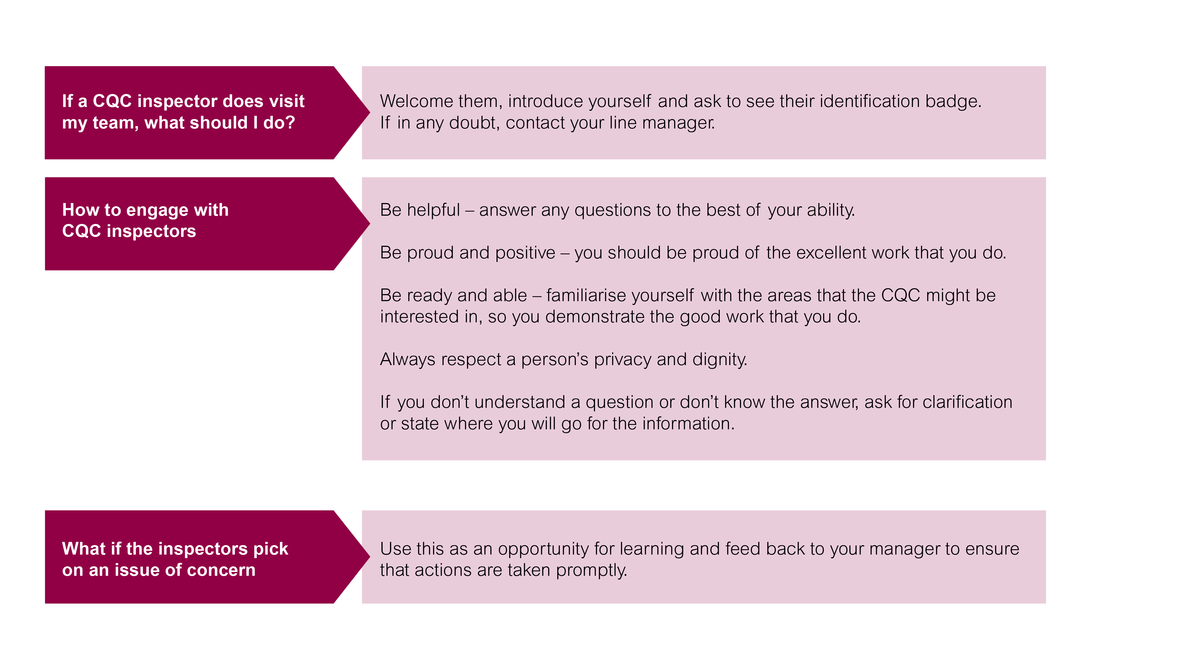

# Things to think about if you are a manager or leader

## Visions and values

Does my service/ area of responsibility have clearly stated aims and objectives and are these owned by colleagues and the people you support?   
Are these discussed and used to help develop my team and how we work?

Evidence  
  
Does everyone understand how they should be recording their work? Is the standard of record keeping reviewed regularly?Can we evidence a person centred, strengths based approach?Can we evidence a commitment to co-production, equality, inclusion and diversity?Are risks and issues identified and mitigated?What data do we collect to monitor performance?Do we have regular opportunities to review performance?Do we share our good practice and innovation?

## Feedback from people who draw on support and their carers

Do we regularly receive feedback and how are we using it?Are we actively seeking feedback from seldom heard groups? Do we share information about incidents, complaints and compliments to ensure themes and lessons can be learnt?Can we provide examples of where changes have been made from feedback? Can we evidence how we ensure we are accessible and responsive to all our communities?

## Feedback from my team

Do I know my vacancy rates, sickness levels and turnover?Are colleagues able to access and participate in continuing professional development – how do I know?How do I assure myself that all staff have appropriate training and induction before they start working in my service and that they feel supported?Is supervision happening?

Are there things that are stopping members of my team doing a great job and what are we doing about them?

## Safeguarding

Do my team know how to raise a safeguarding concern?Do my team know how to access information and support in relation to safeguarding procedures?

# Want to find out more?

If you want to find out more about the CQC approach to assessment of local authority adult social care, there are lots of different resources that are available to you.

We have a dedicated area on our intranet site which….

The Local Government Association and the Association of Directors of Adult Social Services as Partners in Care and Health has developed [a range of resources](https://www.local.gov.uk/our-support/partners-care-and-health/cqcs-new-assurance-framework).

You can also find information on the [CQC website.](https://www.cqc.org.uk/guidance-regulation/local-authorities)