Behavioural insights to reduce waste in Havering – communications:
The images below show the different elements of the Two Bag Challenge communications delivered to residents in the target areas.

Image 1: Waste prevention pack box design

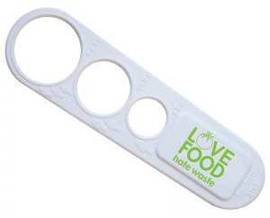
Image 2: Love Food Hate Waste tools
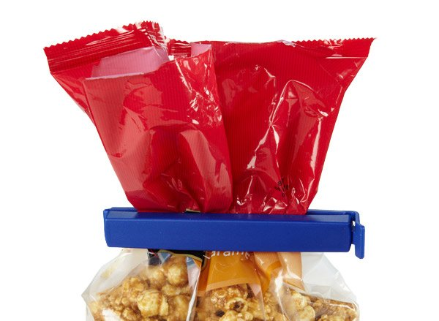
Image 3: General waste bag design
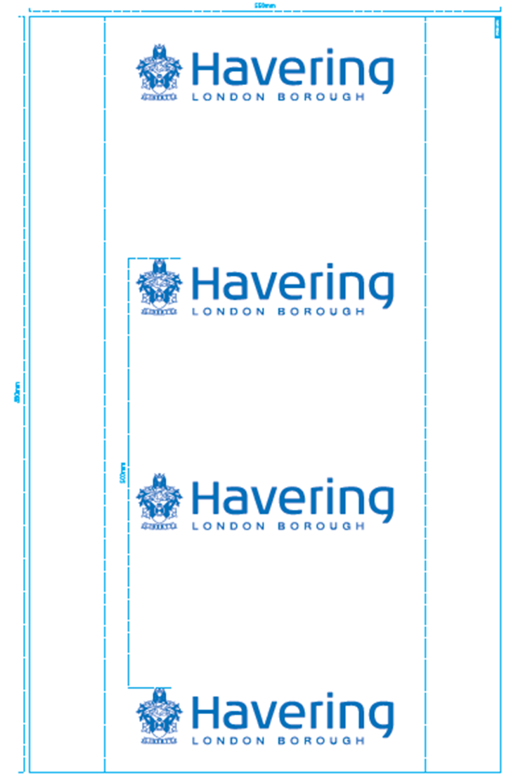
Image 4: Two Bag Challenge letter

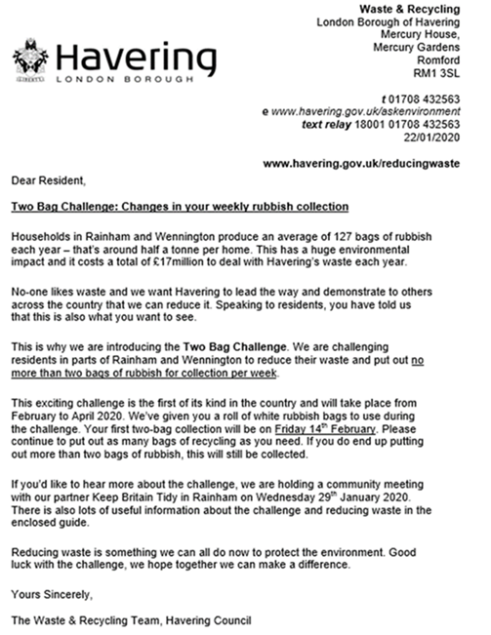

Image 5: Two Bag Challenge waste booklet
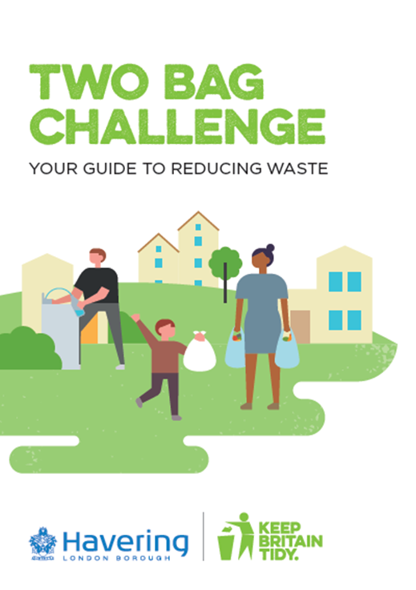
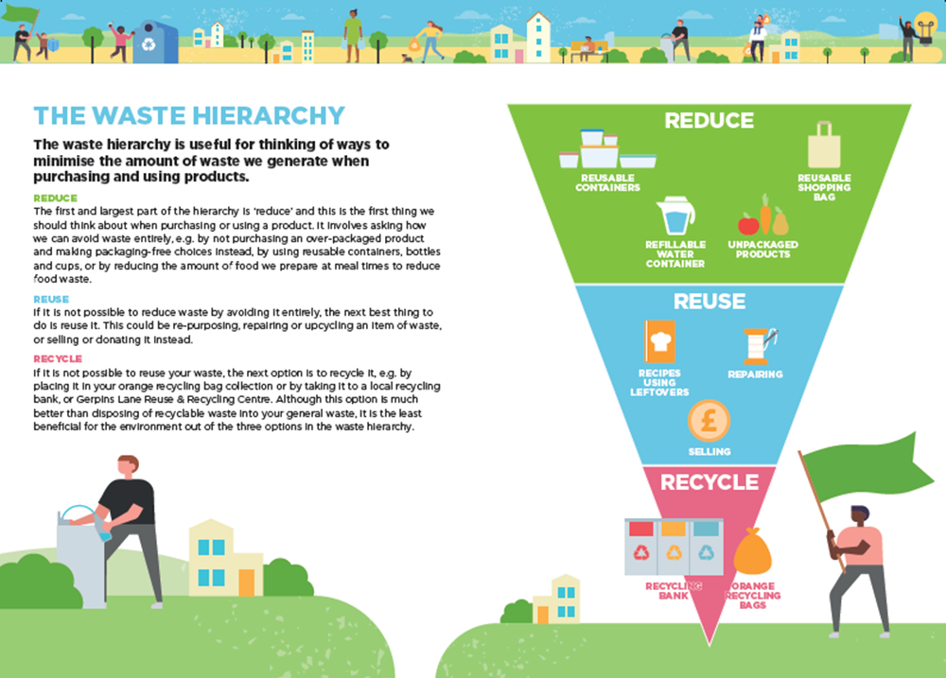
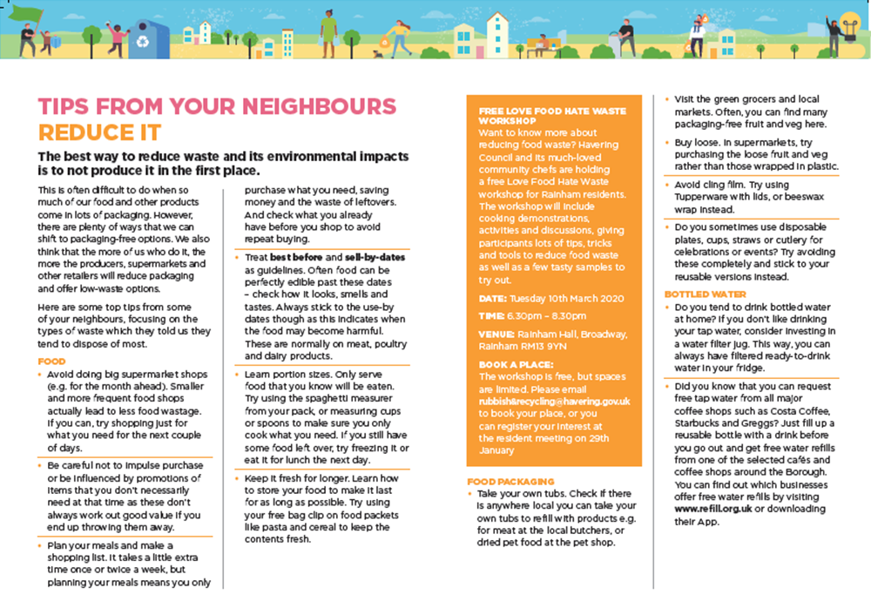
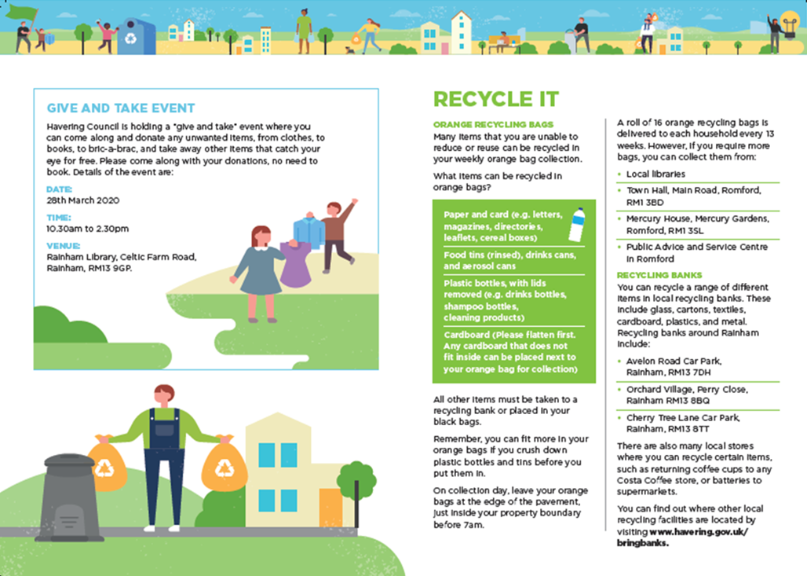
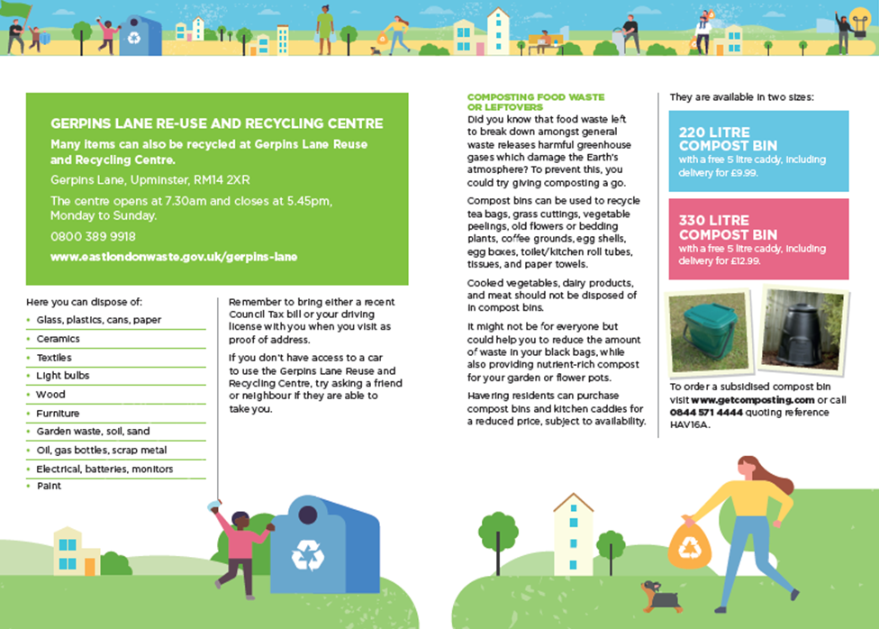
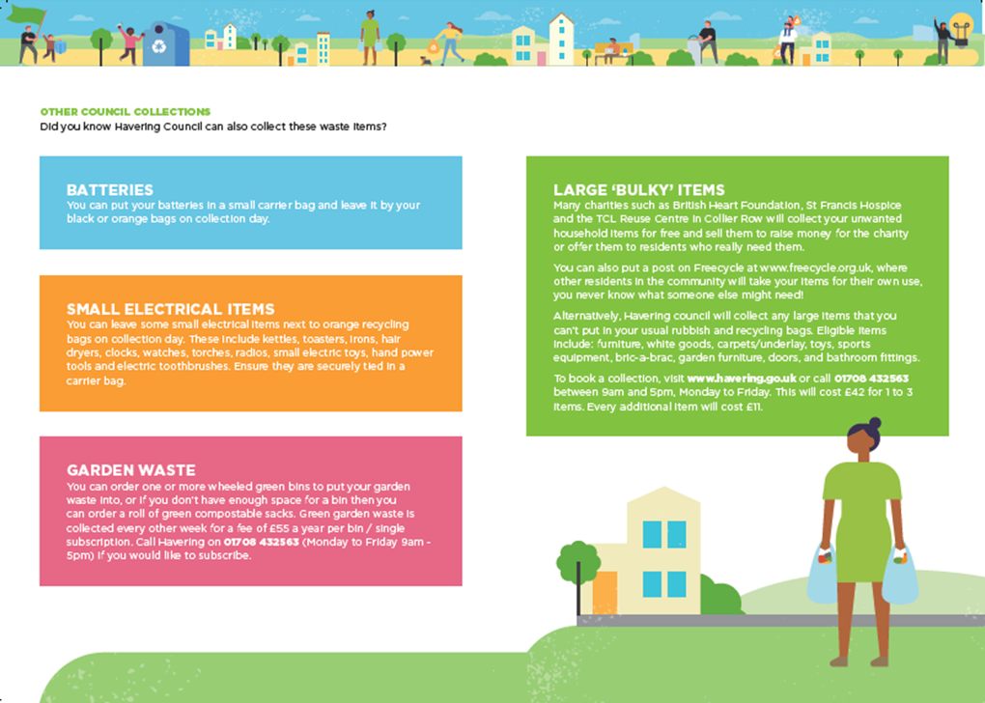
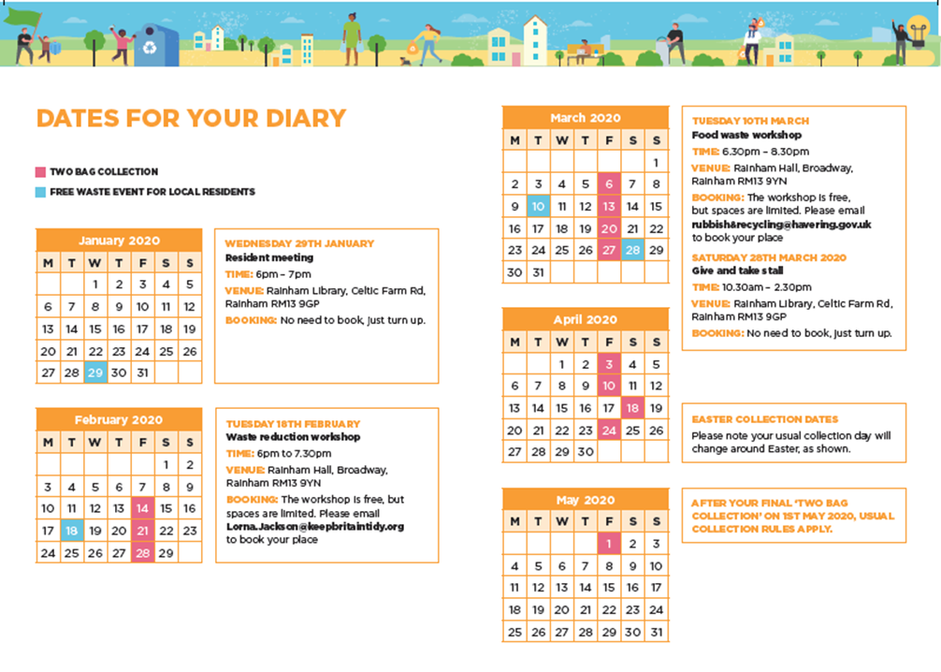
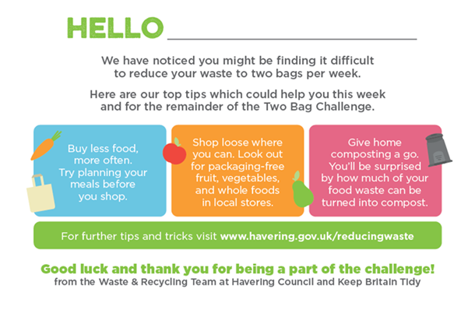
Image 6: Two bag challenge feedback postcard

Image 7: Results feedback leaflet
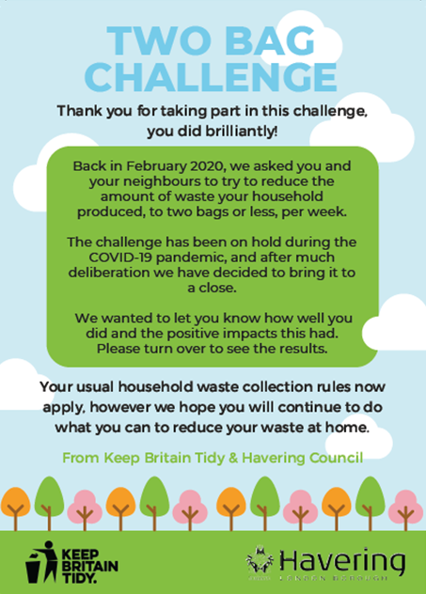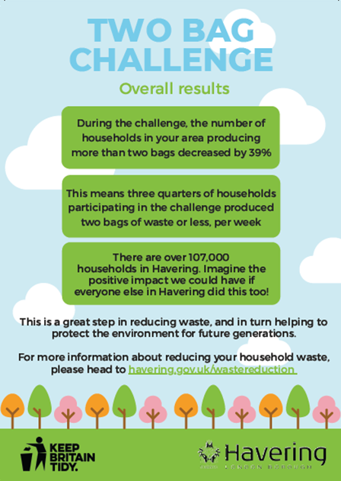

Image 1: Waste prevention pack box design
This shows the design used on the boxes containing residents’ waste reduction packs, which were delivered to doorsteps in the target areas.
Image 2: Love Food Hate Waste tools
These Love Food Hate Waste spaghetti measurers and bag clips were provided within residents’ waste reduction packs, to help them reduce food waste.
Image 3: General waste bag design
This shows the design used on general waste bags delivered to residents for using throughout the Two Bag Challenge.
Image 4: Two Bag Challenge letter
This letter was delivered to residents in their waste reduction packs, informing them about the Two Bag Challenge and why it was taking place
Image 5: Two Bag Challenge waste booklet
This booklet was delivered to residents in their waste reduction packs, informing them further about the Two Bag Challenge, how they can go about reducing waste at home, and how they can manage their waste and recycling effectively.

Image 6: Two bag challenge feedback postcard
This postcard was delivered to residents who were producing more than two bags of general waste for the first two weeks of the challenge. Residents’ house numbers were handwritten onto the postcards, which were then hand delivered through the door or letterbox.
Image 7: Results feedback leaflet
This leaflet was delivered to residents at the end of the Two Bag Challenge to inform them about how much waste had been prevented and the impact this has.

