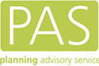

Evidence based research on national best practice in Local Authority approaches to pre-application discussions and Planning Performance Agreements (PPAs)

March 2023

RESEARCH FINDINGS

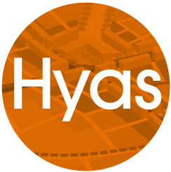

Contents

Desktop review findings 3
Forum findings 4
Councillor workshop findings 7
Questionnaire and interview findings 7
Questionnaire and interview findings: pre-apps 7
Questionnaire and interview findings: PPA 11
Key Findings 14

Desktop review findings

Existing guidance
In 2014 PAS prepared advice on pre-application services and PPAs in its “pre-application suite”. This took the form of six pdfs. Practitioners had advised PAS that they wanted more guidance and assistance with both of these services. This research was intended to support this process.
The pre-application advice element of the suite provided advice and recommendations on the service. The guidance was useful for planners to refer to, albeit it has not been updated since 2014, and was not always representative of the current challenges and needs of local authorities. There was a need for the guidance to be refreshed and replaced to give LPAs the comprehensive knowledge and tools to offer and deliver an efficient and improved pre-application service.
The PPA element of the guidance set out what a PPA is and common attributes, but the bulk of the advice was in the form of FAQs. The ‘examples from local authorities’ section of the suite included links to examples of PPAs from a number of LPAs. The advice and links was useful to a practitioner but did not provide guidance on process or how to put together a PPA.

NPPF and NPPG requirements and guidance
The National Planning Policy Framework (NPPF, 2021) places a presumption in favour of sustainable development towards the management of the built environment. Its aim is to enable a positive approach to decision making and strategic planning to improve the economic, social and environmental aspects of the area.
Paragraph 38 of the NPPF requires Local Planning Authorities (LPAs) to use the full range of planning tools available to enable development, such as pre-application advice and PPAs.
The NPPF highlights the purpose and benefits of pre-application advice. Key points in the NPPF include:
- Better coordination between LPAs and applicants (para 39)
- Improved outcomes (para 39)
- LPA key role to encourage use of service (para 40)
- Resolve issues (para 41)
- Quicker time to make decisions
In addition, the NPPF recognises the potential for voluntary planning performance agreements (PPAs) to achieve ‘a faster and more effective application process’ (paragraph 46) with particular focus on more complex or larger schemes. PPAs, when fully utilised, can become a way of realising better applications for development, creating a closer relationship between applicants and case officers and as a tool to improve the built development.
National Planning Practice Guidance (NPPG) contains a chapter called “before submitting an application” which focuses on pre-application discussions but also this includes a section on PPAs. It builds on the NPPF by providing guidance on process.
This helped to structure the research phase, particularly in seeing if the benefits identified by Government were recognised and shared by practitioners.

Guidance from the Planning Officers Society
The Planning Officer Society (POS) has developed guidance on ensuring good design is considered when dealing with strategic sites. The purpose of the guidance is to ensure good design is embedded throughout the planning process. It aligns the planning process with the RIBA plan of work. The guidance contains advice on pre-application services and PPAs, including a template PPA.
The guidance helped to structure the research phase, particularly when considering community and councillor engagement.

Forum findings
PAS established a forum of Local Government practitioners to share views on pre-application and PPA services and to engage in the research phase of this work. The forum met on a monthly basis from September2022 and the University of Gloucestershire (UoG) and Hyas were invited to attend to obtain first-hand insight regarding pre-application services including PPAs, within LPAs.
On the 6th of September 2022 UoG and Hyas led a segment of the council forum workshop to introduce the project and to get initial views about the current challenges in the use of pre-app and PPA services. The most common challenge identified was resourcing and resources. In addition, the following challenges were identified as the most common answers:
Pre-app challenges | PPA challenges
Resources | Resources
Consultees | Consultees
Time | Time
Benefits not understood | Lack of project management skills
Cost | Experience

The word clouds generated by the sessions were:
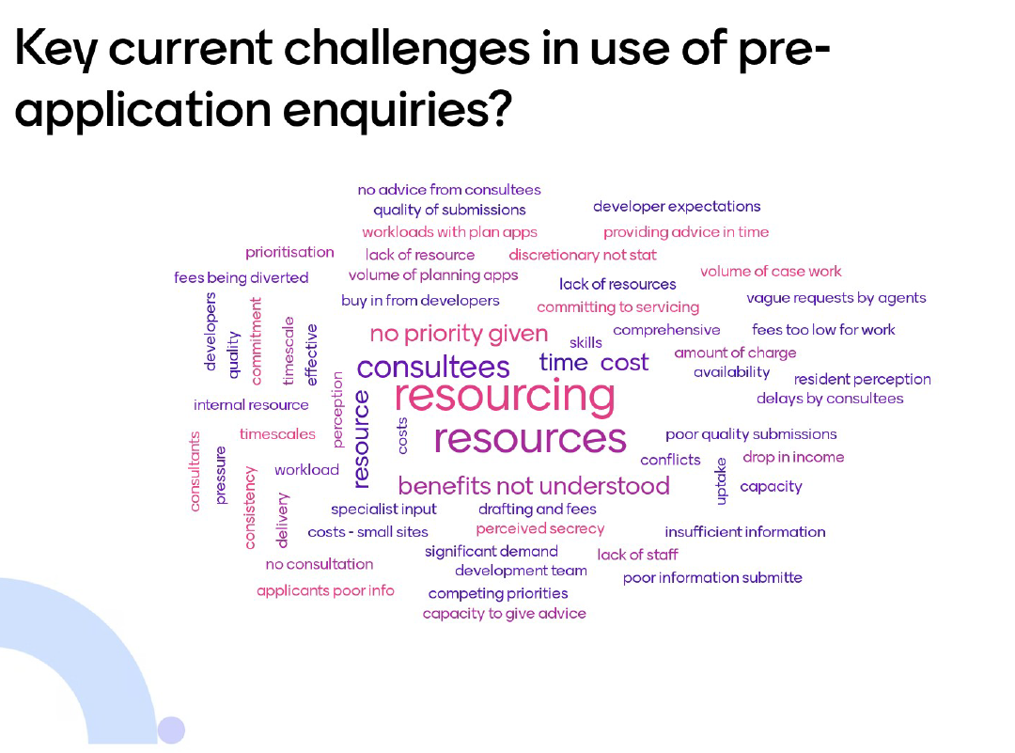
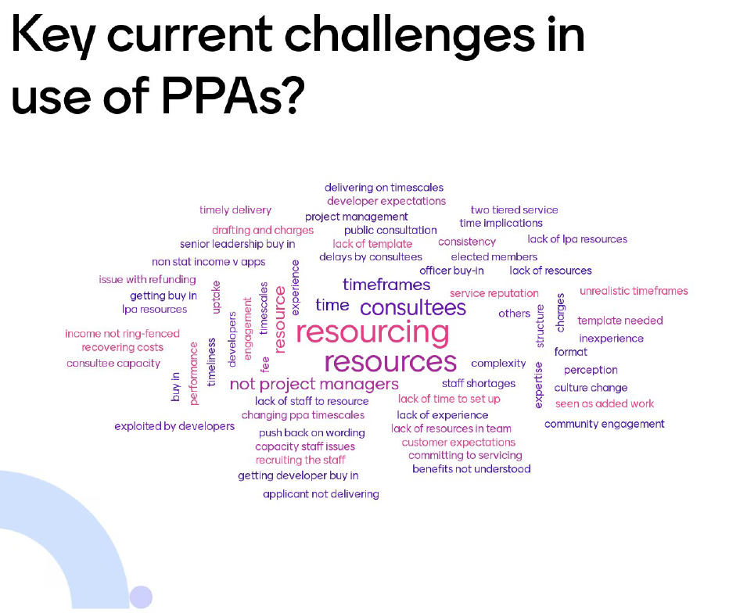

At the Forum meeting held on the 20th of October 2022, UoG and PAS held an interactive session focused on PPAs. The purpose was to understand what practitioners felt would be beneficial from a template, what attributes would be helpful, how flexible they needed it to be and what sort of guidance would be helpful. Key findings were:

What do you consider to be the [potential] added value of a PPA template?

- The ability to manage expectations
- Consistency
- Potential reduction of time
- Smoother process for LPAs and clients
- Open and Transparent
- Less room for error

What attributes/contents within a template are particularly helpful or problematic?

Problematic:
- Lack of flexibility
- Could be restrictive, does it consider timescale amendments, community involvement etc
- Standardised fees, costing may need amending
- Extraneous variables: availability of officers, resources
Helpful
- Clear purpose and objectives
- A cost programme
- Clarity on timescales
- Invoicing: who to be invoiced and when
- Clarify that it does not guarantee planning permissions to be granted
- Include a cap to ensure cost recovery
- A red, amber and green system approach included
- Engagement piece- developers must engage with the community
Thoughts on balance between flexibility and prescription?

- Prescription is good, increases clarity
- Key chapters, headings, and milestones
- The ability to ‘pick and mix’ where applicable
- Use of prompts, to provide guidance without being too prescribed
- A SMART template to allow the application to be tailored to the applicant, whilst still containing elements of prescription
In support of a template, what forms of guidance/ supporting information would be helpful?

- Three variations of guidance: for officers; Councillors; and the public
- Information on levels of responsibility, what happens if it doesn’t go to plan
- Guidance on what should be included
- Costing guidance
- Developer guidance, information on expectations from LPAs
- A ‘How to Guide’ with case study examples for critical parts

Councillor workshop findings

PAS held a workshop with Councillors on the 29th of November 2022 to gain intelligence on councillor involvement and their viewpoint on pre-apps. The key findings were:
- Perceptions of lack of trust
- Misunderstandings of the process
- Range in quality of developer engagement and greater willingness to engage with residents at pre-app
- Councillors feel they can assist the process
The workshop was informed by a questionnaire sent via LGA political group links, the Chief Planner newsletter and social media. In total there were 52 responses. The findings are contained below alongside the questionnaire for professionals involved in the planning process.

Questionnaire and interview findings

Questionnaire and interview findings: pre-apps

Purpose of pre-apps
There was a shared consensus on the purpose of pre-apps which can be summarised as: smoothen the application stage by frontloading the work and promoting early identification of constraints which results in enhancing the quality of the application; to build relationships; a particular benefit for development management on larger or more complex sites; and as a resourcing tool for the public sector bodies. This aligns with the NPPF and Planning Practice Guidance.

The benefits
The research found that the majority of respondents believed that engaging in pre-apps results in building and improving relationships between LPA and applicant, and also other stakeholders. In addition, Councillors felt that pre-apps could lead to better engagement with residents. Other benefits identified included early identification of constraints and potential issues, along with a better quality application submitted and a better quality development outcome.

Experience of use
In general, the research confirmed that the majority of local authorities offer and engage in pre-apps, although some councils currently offered a reduced service or had temporarily suspended the service due to resourcing challenges. A number of people spoke about having to prioritise resources to deal with planning applications as pre-apps were discretionary even though they understood the benefits that pre-apps bring. The property industry and planning consultancies agreed pre-apps are used frequently and on the whole clients are happy to engage in pre-apps.

The Service offered (approach)
There is a clear inconsistency of approach across LPAs in England and across the various types of authorities and even the different approaches of individuals within the same organisation. Some LPAs offer a more informal service which tends to include a brief email exchange, others provide a more formal service which can include a written response or a structured meeting. Applicants expressed their frustration with these inconsistencies and stated sometimes the pre-app route feels unnecessary and there would be greater value in a “quick phone call to advise yes or no”.
There is a lack of consistency in regard to the accessibility of the service. Some LPAs take a digital approach which can consist of access to the pre-app service online. This can take the form of an online submission form with the payment taken online. However, others provide a form which is required to be email or sent via post. Respondents expressed the need for the service to be ‘user-friendly’ and for all information to be accessed in a singular place.
The service offered is nearly always determined by the scale or complexity of the proposal, although applicants expressed their need for flexibility within the pre-app service. They emphasise that a “lengthy written response isn’t always needed” and that they “don’t need policy regurgitated” as often the recipient of the letter tends to be aware of the policy and legislation. Applicants placed emphasis on the value they found in having discussions with LPA planners, particularly on interpretation of policy. The need for flexibility was highlighted throughout this research, as some larger schemes may require less officer time or may not require a meeting. This links to the advice provided by POS that highlights the importance of providing different types of advice dependent on the stage in the development process.
There was a general consensus that there is usually a single point of contact and the case officer who is involved in the pre-app process tended to see the scheme to application stage. Those involved in the pre-app process found a dedicated officer to be beneficial as it promotes familiarity of the scheme and helps improve relationships between parties involved.

The cost of the service and how calculated
There is a lack of consistency around the cost of pre-apps across England. Respondents from various sectors expressed their confusion with the pre-app fee variations from authority to authority; this is evident from the accompanying fee report, which emphasises the inconsistency. Many LPAs communicated the difficulty to generate an ‘average’ which is representative of the hours and time inputted by the dedicated officer, in order to achieve full cost recovery. The lack of consistency of the fees which is presented in the fees report is not limited to the ‘sum to pay’ but the categorisations of the fees as well. Some authorities categorise their pre-app offer by scale of development, others by floorspace and in some cases the fees are determined by the seniority of the officer. LPAs expressed their desire to benchmark and compare their fees to neighbouring or comparative authorities. An increase of consistency in relation to pre-app fees and categorisation would enable LPAs to compare more easily and provide increased clarity for applicants.
There is a lack of transparency around the cost of pre-apps with many applicants expressing their lack of understanding on how the fees are calculated. The research presented various viewpoints and assumptions surrounding the way pre-app fees are calculated. Some knew they were based on officer time (e.g. hourly rate + pensions + other associated costs), others assumed they were generated by benchmarking and others simply were “not sure”. The lack of transparency and understanding results in a lack of confidence from applicants, many expressing their uncertainty on what the income covered and was used for.

The involvement of consultees
The research identified a range of approaches when it came to involvement of consultees. In nearly all cases national consultees such as Environment Agency, Natural England, National Highways and Historic England did not engage in pre-app services with the LPA but provided their own pre-app service, independent of the LPA. Some of those we spoke to recognised the benefits of a more joined up approach with LPAs, even if purchased separately.
Other statutory consultees such as highways and flood teams tended to be consulted by LPAs, as they would on a planning application. There was mixed feedback on the success of this approach. Sometimes these consultees were fully engaged and worked collaboratively with the LPA, for example in a design team approach. This tended to be on larger schemes which benefited from PPAs. However, there were also times where they did not engage, or where their responses were considerably delayed. This lack of a joined-up approach was frustrating for LPAs and applicants. It seems to create a lack of collaboration and communication. LPAs and the applicants clearly prefer to engage with the statutory consultees through a singular pre-app process that allow all responses to be joined up. However, the main barrier for statutory consultees was the perception that they may not recover costs via a single fee charged by an LPA.
Overwhelmingly, the research found that applicants and LPAs perceived that statutory consultees often delay the pre-app process due to the time they take to respond. They also perceived that the quality of their response could be improved. The delay in response from statutory consultees is usually due to a lack of resources, due to the LPA engaging them in the process too late, or the quality of the pre-application submitted. The findings indicate that there is a lack of understanding and communication between different organisations.

The involvement of the community
The findings about the involvement of councillors in the pre-app service is mixed. A small number of LPAs have clear approaches to when and how Councillors are involved. However, most Councils did not have a set approach and undertook ad hoc arrangements depending on the scheme.
There are varied views from all respondents on whether councillors should be involved in the pre-app process, and at what stage in the pre-app process they should be involved. Councillors themselves had different views, as they expressed the main reason they would get involved would be based on whether they were asked. In general, councillors expressed they should be involved in pre-apps, albeit there seemed to be reluctance from some councillors to actually get involved. This reluctance is shared by applicants and some of the LPAs. There is a need for guidance to help explain the benefits of involving Councillors in pre-apps and how their involvement provides value.
Similarly, there are varied views on whether the community should be involved in the pre-app process. There is a perception that community involvement is just a token gesture and there is a sense of “pointlessness” as their involvement lacks impact. The research presented split views on community involvement, many expressed the difficulty of identifying the right stage in the process to involve the community, in order to provide value. From the responses received guidance with regards to community involvement would clearly benefit all involved in the planning process.

Monitoring
There is a lack of monitoring and reviewing, overwhelmingly almost all organisations stated they do not monitor the pre-app process. Many respondents explained they take an adhoc approach in regard to monitoring and reviewing. There was a small proportion of LPAs who monitor and review their pre-app process periodically. However, many statutory consultee organisations do formally monitor, as they are required to hit specific key performance indicators (KPIs) which can only be achieved by systematically monitoring and reviewing the pre-app process.

Barriers to use
The overarching barrier in using pre-apps is the lack of resources within the public sector (LPAs and statutory consultees). This proved to be the main issue in delivering an efficient and effective pre-app service and was emphasised throughout the research. All sectors recognised the lack of resourcing within the public sector. Some LPA and statutory consultees shared that pre-apps are less of a priority than applications, resulting in some LPAs temporarily suspending the pre-app service or declining to engage in the pre-app when resources are tight. Many LPAs and statutory consultees (when the pre-app is via the LPA) partially associated the under-resourcing of their department as a consequence of not achieving full cost recovery on pre-application services.
A negative perception of pre-apps was identified as a barrier by some. This mainly related back to poor experiences linked to time taken to receive the service and the quality of the service received. Applicants advised that clients were happy to pay for the pre-app service if they felt they were receiving added value but the research also found that some felt engaging in pre-apps was not always “worth it”. There were some views expressed that it was quicker and most cost effective to utilise the “free-go” route by submitting an application, rather than going down the pre-app route. Many highlighted that for pre-apps to be perceived as value for money, an efficient and effective service needs to be delivered and the benefits need to be emphasised to the applicant.

Questionnaire and interview findings: PPA

Purpose of PPAs
In general, organisations recognised that PPAs are designed as a project management tool for larger and more complex sites, and specifically to: (1) reduce timescales; (2) dedicate officer time; (3) build relationships; (4) produce better quality development outcomes; (5) provide a collaborative approach; (6) and a resourcing tool for local authorities. Although most recognised PPAs were designed as a project management tool, aligned with Government guidance, many highlighted that local authorities’ current motivation was often to engage in PPAs for additional income. This seemed to occasionally result in a lack of perceived value by the client, as the service does not always meet expectations. There was a general consensus that all sectors would like PPAs used as project management tool, in order to deliver and receive a good and efficient service which meets timescales and promotes a collaborative way of working.
Councillors are not normally directly involved in the process of putting a PPA together. The research found some LPAs and applicants felt there was a lack of understanding from councillors about the purpose of PPAs and their value. Several respondents felt there was a perception from councillors that a PPA meant “buying” permission, or pre-empting the process.
The purpose of PPAs clearly needs to be better explained to those involved.

The benefits
There was a general consensus that engaging in a PPA results in improved relationships between involved parties and enables relationships between stakeholders to be developed. The PPA process was referred to as an “enhanced service” and a “fast pass” (to a decision). The research suggested that timescales were not always met, sometimes due to factors outside of the control of the applicant and LPA such as statutory consultees. However, the benefits experienced through engaging in a PPA seemed to outweigh the negatives.
There were many experienced benefits of engaging in PPAs presented throughout the research which were: (1) better quality of development; (2) better quality of application submitted; (3) income generation for LPAs; (4) shorter time to consider an application; and (5) specialist staff to be resourced. These benefits were outcomes of good PPA process experiences. However, these benefits were not often clearly spelled out.

Experience of use
The research identified that there was limited experience of the use of PPAs within LPAs. Although many authorities have used PPAs, the use of them was ad hoc. When PPAs were rarely used by LPAs this seemed to result in a lack of confidence from all parties involved and a lack of understanding from LPAs with regard to the process and delivery of a PPA. However, the LPAs who engage in PPAs more regularly are comfortable with the deliverability of the PPA service.

The service offered (approach)
Whilst PPAs traditionally have been used for the pre-app and application process, they are being used now in local plan preparation, discharge of conditions, reserved matters and monitoring.
In a similar way to the pre-app approach, there tends to be a dedicated officer who will see the PPA from start to finish. However, where a PPA covers a complex site or a lengthy process such as pre-app through to reserved matters, applicants recognised this may not always be possible and there can be situations outside of the control of the LPA such as officer turnover or sickness. All expressed a single point of contact / dedicated officer is needed when entering a PPA. The research identified examples of LPAs establishing a team of officers, with junior officers supporting a more senior case officer to provide continuity and resilience which was welcomed.
There was a general consensus that the PPA service offered is and should be bespoke to the specific scheme/development, which enables the service and resources to be tailored to specific proposals. Although the service needs to be bespoke, many shared the similar viewpoint that there needs to be a level of standardisation to the PPA service across LPAs in England to encourage consistency of approach. There is a need for the appropriate balance of prescription and flexibility, to enable the service to be most effective.

The cost of the service and how this is calculated
As with pre-app fees there is a lack of consistency and transparency across LPAs in England. This is supported by the data collected and included within the fees report. Many LPAs refrain from publishing PPA fees via their website due to the bespoke nature of the PPA process, albeit there are some authorities that have accessible PPA fees online. However, organisations involved in the PPA process acknowledge the challenge of providing costings in regard to the PPA process particularly as scheme requirements can vary vastly. There is a need for PPA fees to be transparently calculated to provide the applicant and all parties involved increased understanding on the details of the service (e.g., meetings, officer time). Applicants referred to costs being “plucked out of thin air”.

The involvement of consultees
Third parties such as statutory consultees were rarely signatories to a PPA. The research identified a small number, such as Essex County Council, that offered the opportunity for a PPA directly with them. So, in the majority of cases statutory consultees were involved in the same way as they would with an application without a PPA. The result of this, which was highlighted by applicants, was that timescales could be delayed and there was no route or recourse to the statutory consultee.
Many applicants expressed their frustration with statutory consultees being a separate entity that could reduce the collaborative nature of the PPA process.

The agreement
The research highlighted a need for a high-level flexible framework to assist with preparing a PPA. Some local authorities provide a PPA template, however the research highlighted the inconsistency across LPAs in England and the need for the PPA to be bespoke to the application. All sectors agreed there needs to be the right balance between prescription and flexibility, in order to tailor the PPA’s attributes to the specific proposal.
There was a clear need for the agreement to be clear and easy to use, but many expressed that respondents thought PPAs can be lengthy, too legalistic or even in some cases too simplistic. There is a clear need for the PPA to include certain information such as: key dates/milestones; a programme; contact list; key legal information; charging schedule including resources; meetings; and performance standards.
Many expressed that PPAs can be too legalistic. Concerns were raised about the time taken to finalise the agreement, once legal teams were involved. This further emphasises the need for the agreement to be clear, concise and easy to use.

Project Management
It was reported that LPA staff were not confident in their project management skills seemingly believing their day-to-day skills did not include project management.
There were a small number of LPAs who had a number of concurrent PPAs that were using dedicated staff to manage PPA processes. They were in effect acting as programme managers, setting up meetings, organising invoices, checking on key milestones and programmes. This had benefits to the case officer and support team in that they were able to focus on the planning issues.
There were instances where LPAs and applicants highlighted that bringing in resources to either backfill officer time or to work on PPAs could delay progress on the PPA. This was down to Council governance and financial procedures for purchasing services. The research identified that some LPA officers had a lack of understanding about how their council’s procurement process worked and ways to speed up those processes.

Monitoring
The research presented a lack of monitoring of PPAs taking place. The research found almost no council formally monitors the PPA process. It appeared that the majority of organisations adopt an ad hoc approach in regard to monitoring. There was no significant explanation given to the lack of monitoring. There was a small proportion of applicants who stated they review and monitor PPAs to ensure they are getting “their monies worth”. LPAs recognised that monitoring and reviewing their PPA process could be beneficial, to improve the positive outcomes and enhance the efficiency of the service.

Barriers to use
The barrier which frequently reoccurred throughout the research was the lack of resources within LPAs as a PPA requires a certain level of service to be delivered. LPAs expressed their concerns that PPAs require a significant amount of officer time to put together and deliver. This can result in large strains on resources within LPAs, particularly if the income generated from the PPA is not used to backfill existing posts.
There appeared to be a lack of understanding / knowledge / confidence in PPAs from some respondents, as they seemed to be a tool which is under used and knowledge was limited across the planning sector. There was a clear desire for LPAs to offer and engage in the PPA process, albeit some were reluctant due to their lack of confidence in regard to delivering a good PPA service. LPAs generally saw the benefit from standardised PPA guidance and a PPA template to shape and structure the service / process.

Key Findings

The key findings identified can be summarised as:
- Shared consensus about the purpose of pre-apps.
- General consensus that pre-apps and PPAs can lead to better working relationships, better engagement, early identification of constraints and issues, better quality applications, income generation to support the service provided including specialist staff, shorter timescales for decision making and better quality built development.
- A lack of understanding of the benefits of pre-application advice and PPAs amongst, in particular, councillors and across councils.
- PPAs are used much less widely than pre-application advice.
- Innovative uses of PPAs include Local Plan making, discharge of conditions and monitoring.
- Innovative approaches to PPAs including regular income, supporting specialist work and dedicated PPA officers.
- Applicants are willing to pay for the service if the service promised is delivered.
- Applicants value LPA officer views and the ability to discuss matters.
- LPA staff were not confident about their project management skills.
- Pre-application and PPA service offers are not always flexible enough to provide the products applicants are seeking.
- Fees are difficult to calculate as councils do not show how they have been calculated and fees and their respective offers differ greatly between authorities.
- There is hesitancy in setting up a PPA service as it is deemed to be time consuming and a considerable change in services offered.
- The ability to speak to an officer via use of pre apps and PPAs is highly valued amongst applicants.
- There is a lack of monitoring of the time spent on pre-application advice and PPAs.
- There is a lack of monitoring of the impact of pre-application advice and PPAs have on the application process, both in terms of time taken and decision made e.g. does the use of a pre-application service generally increase the proportion of approved applications?
- There is a lack of monitoring or review of the outcomes of pre-application advice or PPAs on the quality of built development.
- Collaboration between councils and statutory consultees (both internal and external) can be problematic due to some statutory consultees charging for their own advice and because responding to pre-application advice is not mandatory for statutory consultees in most cases.
- The community, community organisations, and Councillors are rarely engaged during pre-application discussions.
- There is no consistency in how the community are engaged.
- There is willingness from the private sector to seek views from Councillors.
- LPAs, applicants, Councillors and the community are not clear when the most appropriate stage of pre-application is for engagement to take place.
- Guidance is not often placed on websites to alleviate the need for more commonly asked for advice.

